CHAPTER 10: Heat and electricity
Worksheet 10.6

Testing batteries
Science Quest 9: pages 365–6
Student: Class:

Battery basics
1. Batteries were first invented about 200 years ago. Our modern society makes greater use of batteries than at any time in the past.
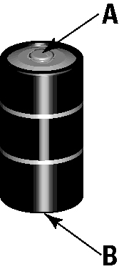 | (a) Examine a battery at home. Identify which end of the battery (A or B) is the positive pole.  (b) Identify four common uses of batteries.  (c) Identify a common battery that is not rechargeable.

Testing AA
2. A student decided to conduct a series of fair tests to determine what brand of AA dry cell would be best to power her portable music player for the longest time. Answer the following questions about the design of her investigation.
(a) Identify the independent variable to be tested.
(b) Identify the dependent variable that could be measured.

(c) Identify two variables that will need to be controlled.

(d) Explain how the student can improve the reliability of her investigation.

Keep it cool?
3. Another student read that the best strategy to ensure a long battery life is to store the batteries in the refrigerator when not in use. He decided to investigate this claim.
(a) State the hypothesis that this student would write in his report.

(b) Write a brief method for the investigation that this student will undertake. Make sure you write the method as a series of numbered steps. Clearly identify the independent and dependent variable and include repetition of the experiment.

